Patron and Honorary Member H.R.H. The Princess Royal

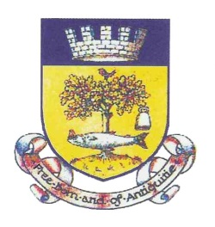

INSTITUTED 1756

THE GRAND ANTIQUITY SOCIETY of GLASGOW

INCORPORATED BY ROYAL CHARTER 1899

**NEAR HAND APPLICATION**

**ENTRY MONEY IF AGED UNDER 25 YEARS - £40**

**ENTRY MONEY IF AGED OVER 25 YEARS - £80**

|  |  |
| --- | --- |
| FULL NAME OF APPLICANT |  |
| OCCUPATION |  |
| DESIGNATION – Mr/Mrs/Miss/Dr etc |  |
| ADDRESS |  |
| POSTCODE |  |
| CONTACT TEL NO |  |
| EMAIL ADDRESS |  |
| DATE OF BIRTH |  |
| DATE OF BURGESS TICKET |  |
| FATHER’S OR MOTHER’S NAME IF JOINING AS A SON OR DAUGHTER |  |
| FATHER-IN-LAW’S OR MOTHER-IN-LAW’S NAME, IF JOINING AS A SON-IN-LAW OR DAUGHTER-IN-LAW |  |
| DATE OF ADMISSION OF FATHER OR MOTHER, OR FATHER-IN-LAW OR MOTHER-IN-LAW AS A MEMBER OF THIS SOCIETY |  |

Signature of Applicant ………………………………………………..

Date………………………………………………………………………..

**Office use only** :

Date Application received ………………………………………………………………

Date Application placed before Directors ……………………………………………

Date Burgess Ticket Applied for ………………………………………………………

Scottish Charity No. SC003224