Patron and Honorary Member H.R.H. The Princess Royal

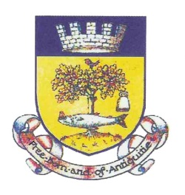

INSTITUTED 1756

THE GRAND ANTIQUITY SOCIETY of GLASGOW

INCORPORATED BY ROYAL CHARTER 1899

**FAR HAND APPLICATION**

**ENTRY MONEY IF AGED UNDER 25 YEARS - £40**

**ENTRY MONEY IF AGED OVER 25 YEARS - £80**

|  |  |
| --- | --- |
| FULL NAME OF APPLICANT |  |
| DESIGNATION – Mr/Mrs/Miss/Dr etc |  |
| ADDRESS |  |
| POSTCODE |  |
| CONTACT TEL NO |  |
| EMAIL ADDRESS |  |
| DATE OF BIRTH |  |
| DATE OF BURGESS TICKET |  |
| NAME & DATE ON FATHER’S/MOTHER’S/HUSBAND’S/WIFE’S BURGESS TICKET, OR ON FATHER-IN-LAW OR MOTHER-IN-LAW’S BURGESS TICKET |  |
| NAME AND DATE ON GRANDPARENT’S OR GRANDPARENT’S IN LAW BURGESS TICKET IN DIRECT LINE |  |
| PARTICULARS OF OTHER BURGESS TICKETS IN DIRECT LINE BEYOND THOSE NAMED ABOVE IF KNOWN |  |

Signature of Applicant ………………………………………………..

Date………………………………………………………………………..

**Office use only** :

Date Application received ………………………………………………………………

Date Application placed before Directors ……………………………………………

Date Burgess Ticket Applied for ………………………………………………………

Scottish Charity No. SC003224